**ASWIN J**

**231501026**

**DATE:**

**WEB TECHNOLOGY AND MOBILE APPLICATIONS**

**EXPERIMENT-1**

**AIM:**

HTML &amp; CSS

a) Create a web page to embed a map along with hot spot, frames &amp; links.

b) Create a web page using an embedded, external and inline CSS file.

**CODE:**

**a.**

<!DOCTYPE html>

<html lang="en">

<head>

    <meta charset="UTF-8">

    <meta name="viewport" content="width=device-width, initial-scale=1.0">

    <title>Interactive World Map</title>

    <style>

        body {

            font-family: Arial, sans-serif;

            background-color: #f4f4f4;

            text-align: center;

            margin: 0;

            padding: 20px;

        }

        .container {

            background: white;

            padding: 20px;

            border-radius: 10px;

            box-shadow: 0px 0px 10px rgba(0, 0, 0, 0.1);

            max-width: 800px;

            margin: auto;

        }

        h2 {

            color: #333;

        }

        .map-container {

            display: flex;

            justify-content: center;

            align-items: center;

            margin: 20px 0;

        }

        img {

            max-width: 100%;

            height: auto;

            border-radius: 10px;

        }

        ul {

            list-style: none;

            padding: 0;

        }

        li a {

            text-decoration: none;

            color: #007BFF;

            font-weight: bold;

        }

        iframe {

            border-radius: 10px;

            width: 100%;

            height: 400px;

            border: none;

        }

    </style>

</head>

<body>

    <div class="container">

        <h2>Explore the World Map</h2>

        <p>Click on the highlighted areas to learn more.</p>

        <div class="map-container">

            <img src="img1.jpg" usemap="#worldmap" alt="World Map">

        </div>

        <map name="worldmap">

            <area shape="rect" coords="120,180,180,240" href="https://en.wikipedia.org/wiki/United_States" alt="USA">

            <area shape="rect" coords="850,350,900,400" href="https://en.wikipedia.org/wiki/India" alt="India">

        </map>

        <h3>Quick Links:</h3>

        <ul>

            <li><a href="https://www.google.com/maps" target="_blank">Google Maps</a></li>

            <li><a href="https://www.bing.com/maps" target="_blank">Bing Maps</a></li>

        </ul>

        <h3>Embedded Google Maps</h3>

        <iframe src="https://www.google.com/maps/embed?pb=!1m18!1m12!1m3!1d3151.8354345093707!2d144.95373631531963!3d-37.81627937975171!2m3!1f0!2f0!3f0!3m2!1i1024!2i768!4f13.1!3m3!1m2!1s0x6ad642af0f11fd81%3A0xf5772c53a8ef1b87!2sMelbourne%20VIC%2C%20Australia!5e0!3m2!1sen!2sus!4v1605250581944!5m2!1sen!2sus"></iframe>

    </div>

</body>

</html>

**b.**

try.html

<!DOCTYPE html>

<html lang="en">

<head>

    <meta charset="UTF-8">

    <meta name="viewport" content="width=device-width, initial-scale=1.0">

    <title>CSS Styling Example</title>

    <!-- External CSS -->

    <link rel="stylesheet" href="styles.css">

    <!-- Embedded CSS -->

    <style>

        h1 {

            color: blue;

            text-align: center;

        }

        .embedded-style {

            font-size: 18px;

            color: green;

            border: 2px solid black;

            padding: 10px;

        }

    </style>

</head>

<body>

    <h1>Welcome to the Styled Web Page</h1>

    <p style="color: red; font-size: 16px;">This is an inline CSS example.</p>

    <p class="embedded-style">This paragraph is styled using embedded CSS.</p>

    <p class="external-style">This paragraph is styled using external CSS.</p>

</body>

</html>

Styles.css

.external-style {

    font-size: 20px;

    color: purple;

    background-color: lightgray;

    padding: 10px;

    border-radius: 5px;

}

**OUTPUT:**

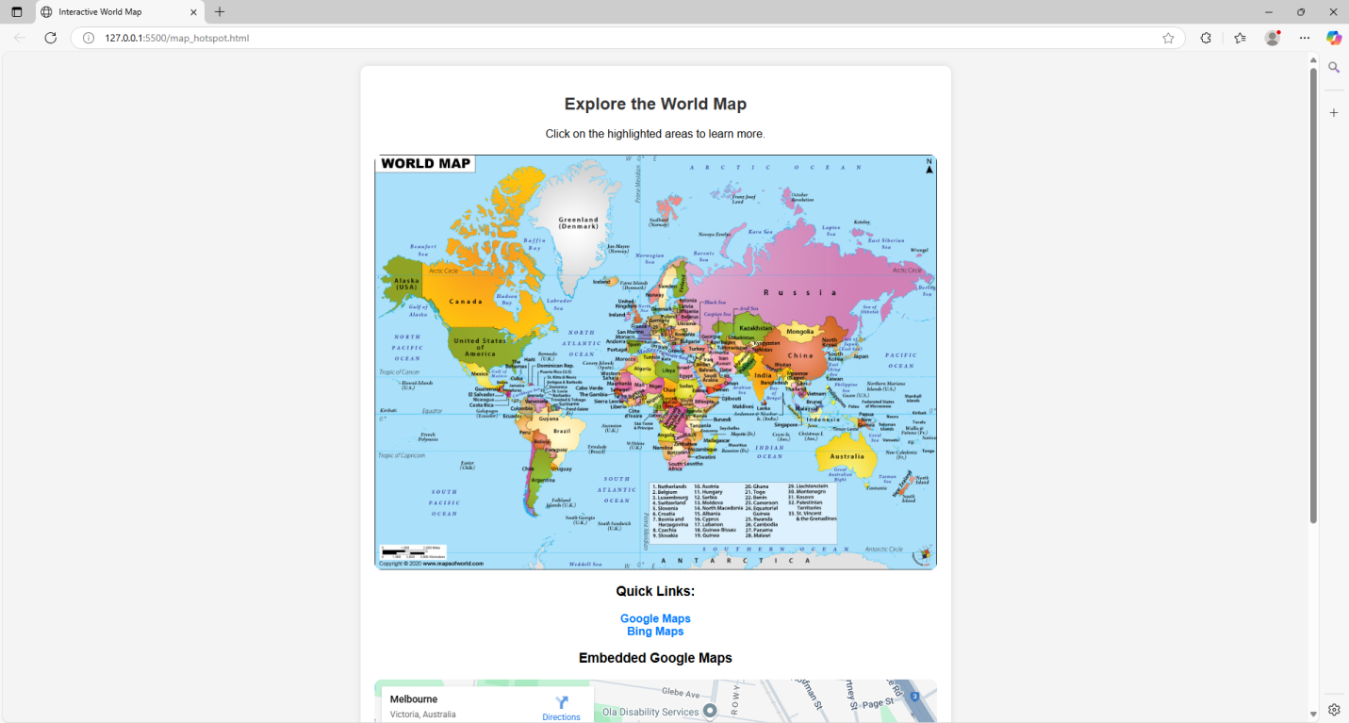

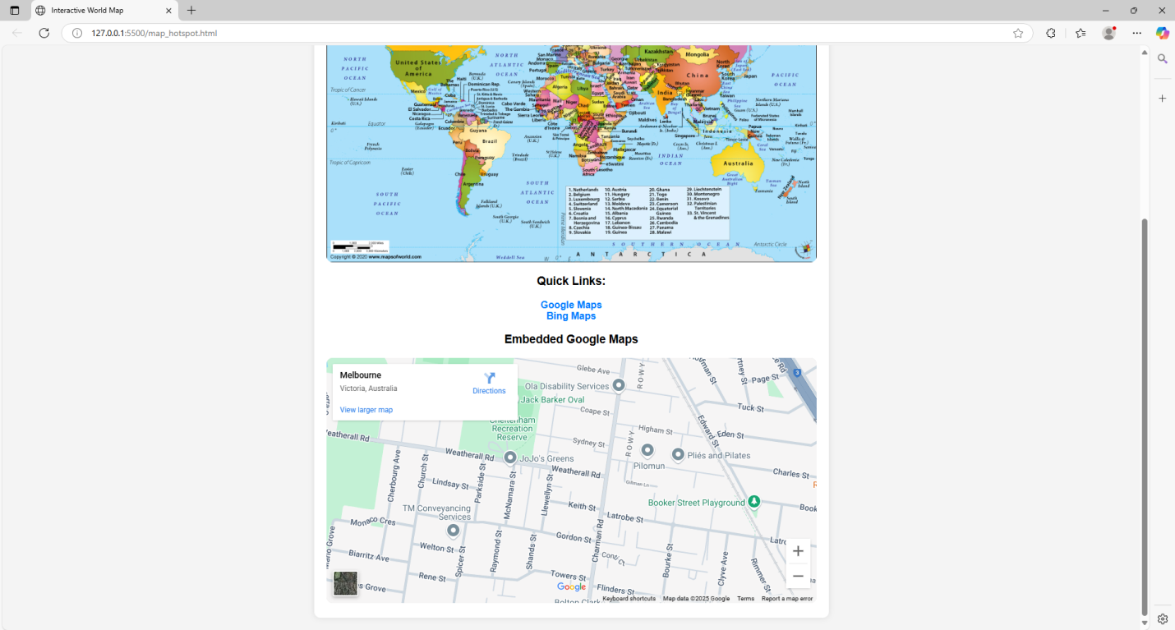

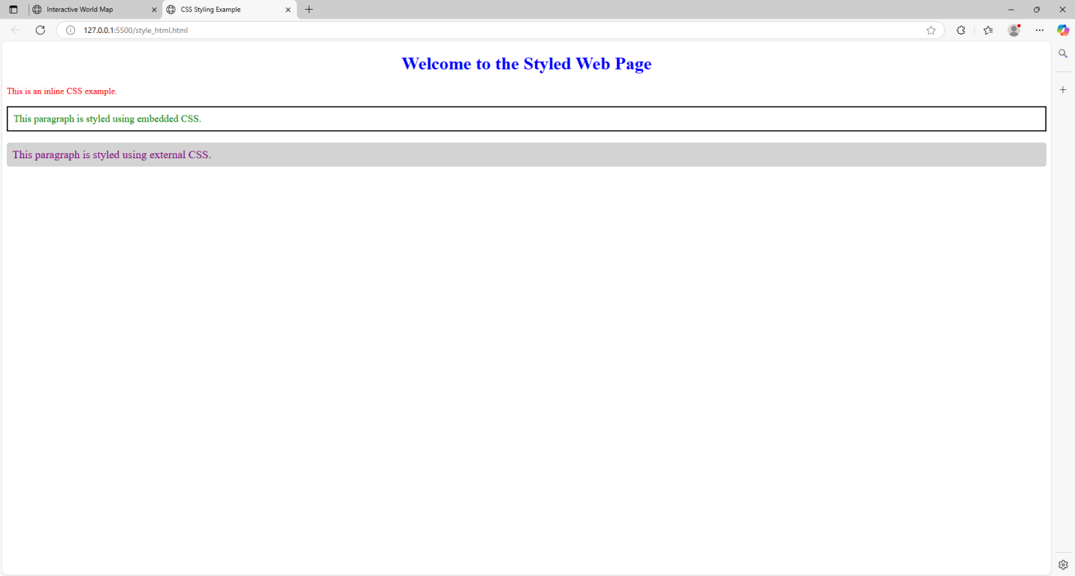

**Result**: Thus, a basic webpage with embedded maps, and a webpage illustrating different css was completed successfully.